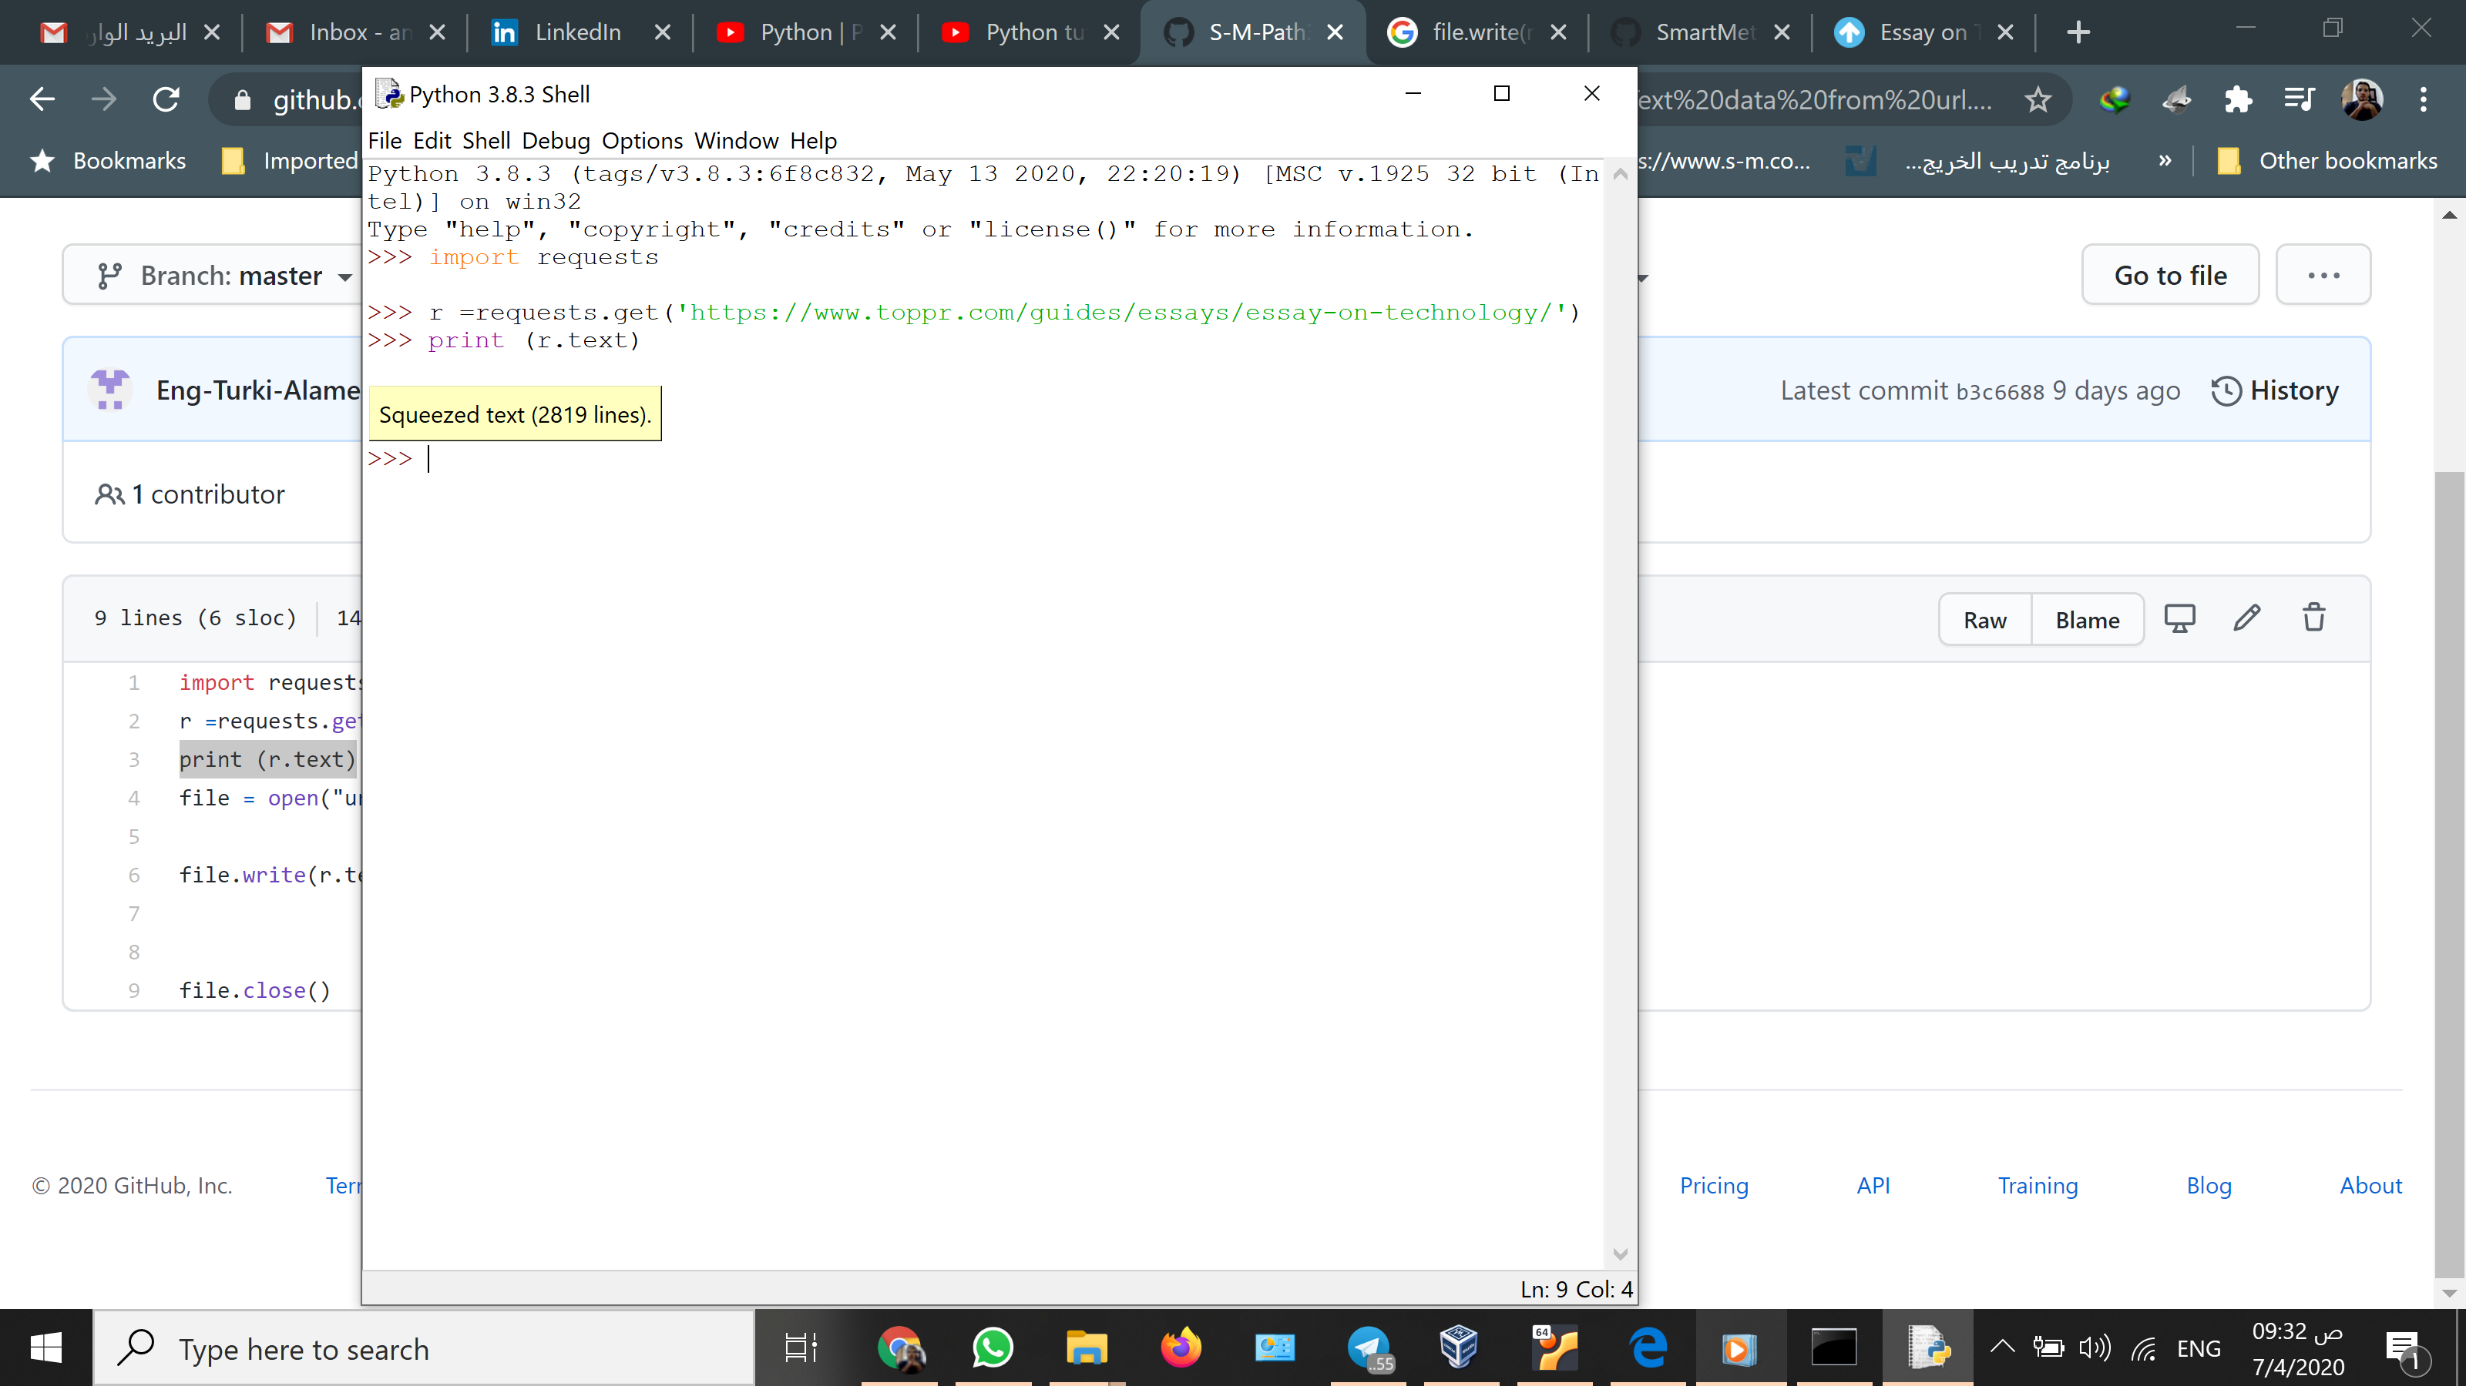

After I installed python then I installed the requests library by using command pip install requests

After the I picked a link url that we will get our information from using the requests

<https://www.toppr.com/guides/essays/essay-on-technology/>

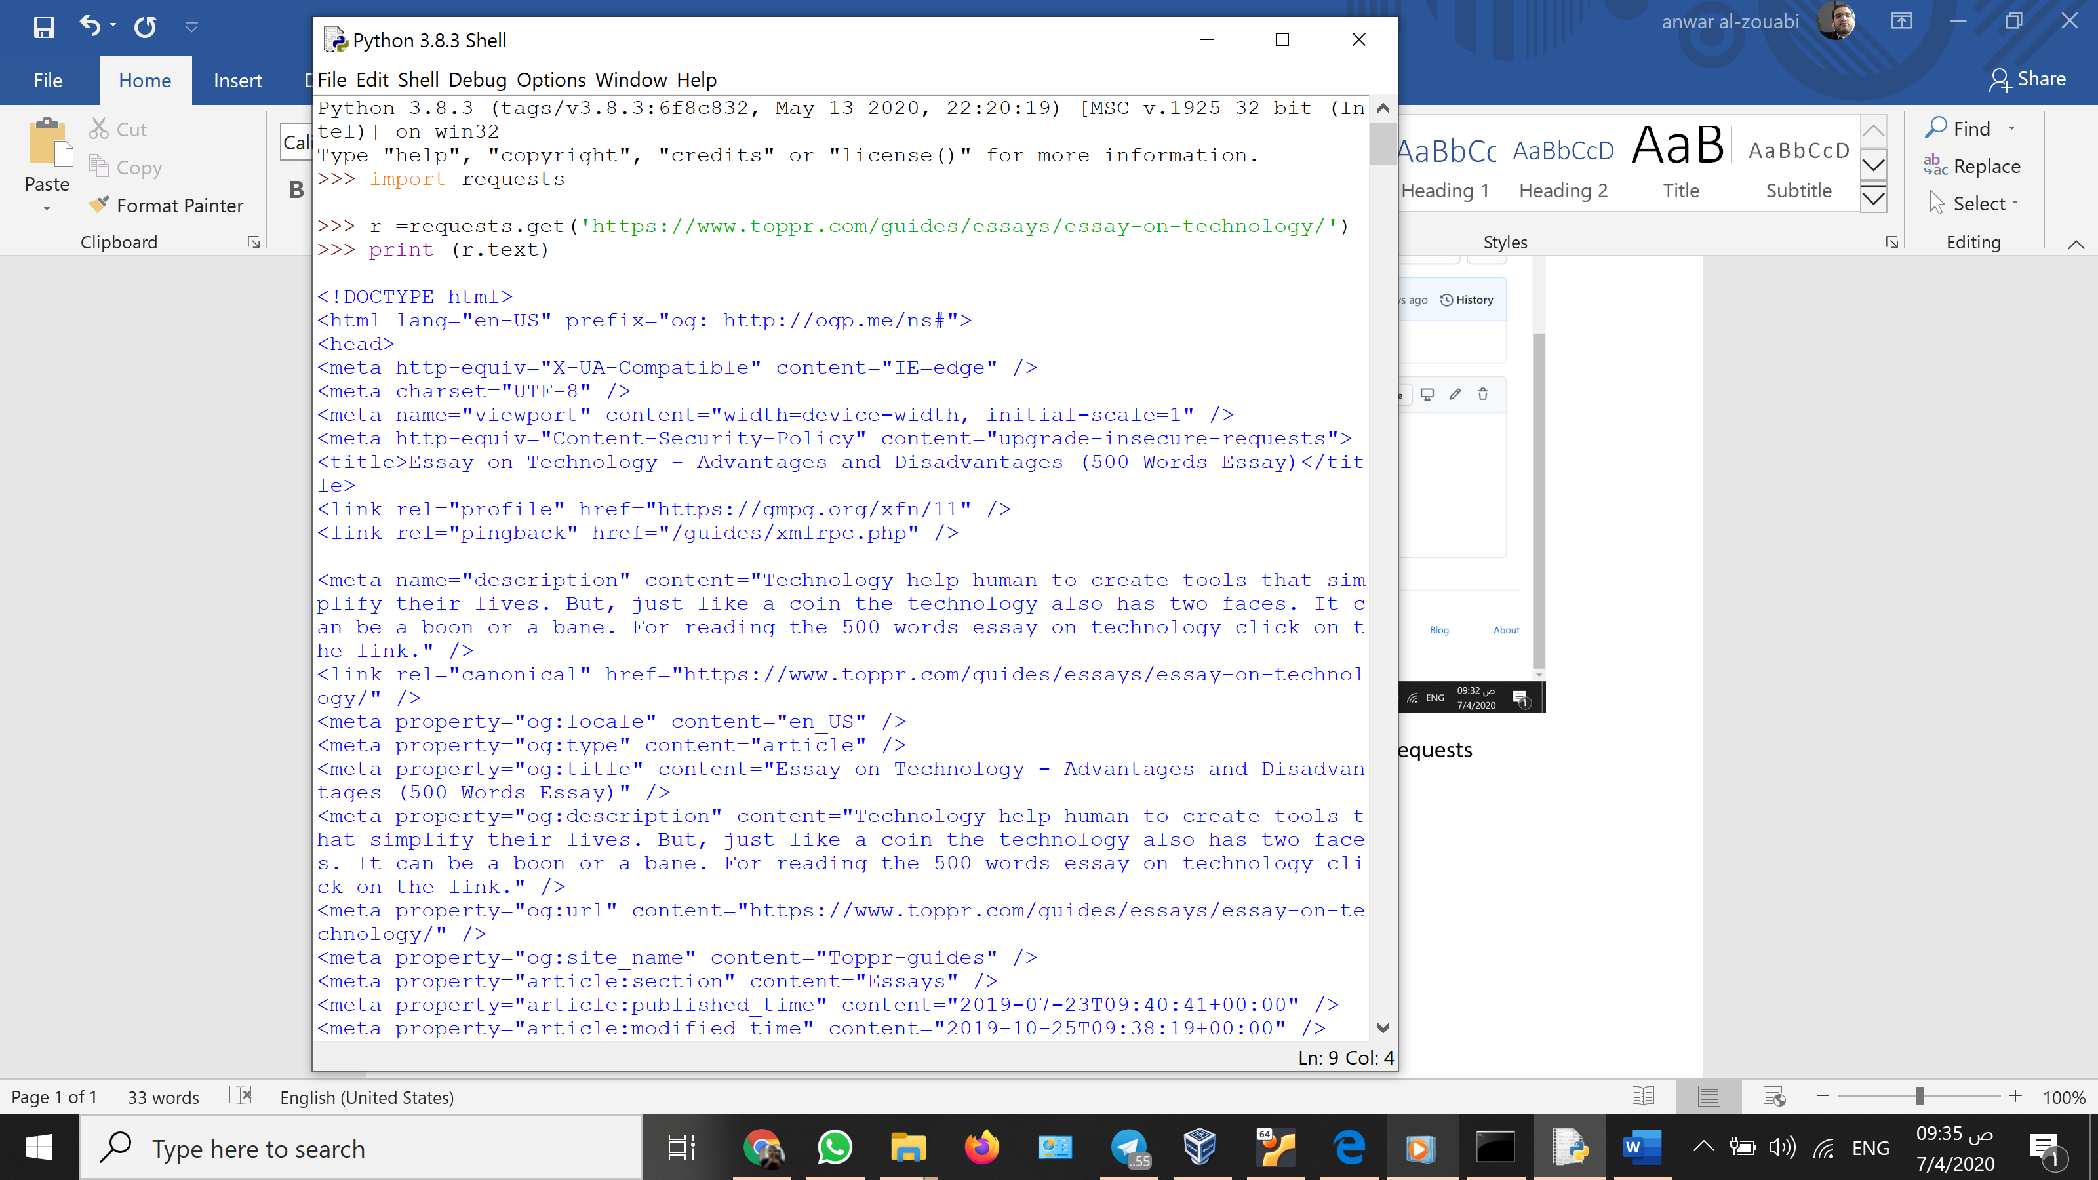

That’s all for this task hopefully I did what’s asked from me